**Create an MVC Web Application**

**Change Authentication -> No Authentication**

Open *Views\Shared\_Layout.cshtml*

<!DOCTYPE html>

<html>

<head>

<meta charset="utf-8" />

<meta name="viewport" content="width=device-width, initial-scale=1.0">

<title>@ViewBag.Title - Contoso University</title>

@Styles.Render("~/Content/css")

@Scripts.Render("~/bundles/modernizr")

</head>

<body>

<div class="navbar navbar-inverse navbar-fixed-top">

<div class="navbar-inner">

<div class="container">

<button type="button" class="btn btn-navbar" data-toggle="collapse" data-target=".nav-collapse">

<span class="icon-bar"></span>

<span class="icon-bar"></span>

<span class="icon-bar"></span>

</button>

@Html.ActionLink("Contoso University", "Index", "Home", null, new { @class = "brand" })

<div class="nav-collapse collapse">

<ul class="nav">

<li>@Html.ActionLink("Home", "Index", "Home")</li>

<li>@Html.ActionLink("About", "About", "Home")</li>

<li>@Html.ActionLink("Students", "Index", "Student")</li>

<li>@Html.ActionLink("Courses", "Index", "Course")</li>

<li>@Html.ActionLink("Instructors", "Index", "Instructor")</li>

<li>@Html.ActionLink("Departments", "Index", "Department")</li>

</ul>

</div>

</div>

</div>

</div>

<div class="container">

@RenderBody()

<hr />

<footer>

<p>&copy; @DateTime.Now.Year - Contoso University</p>

</footer>

</div>

@Scripts.Render("~/bundles/jquery")

@Scripts.Render("~/bundles/bootstrap")

@RenderSection("scripts", required: false)

</body>

</html>

**Install Entity Framework 6**

Install-Package EntityFramework

**Create the Data Model**

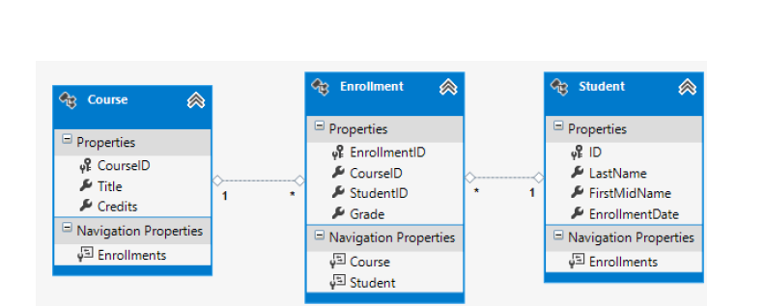

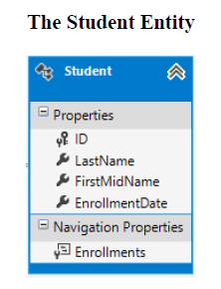

using System;

using System.Collections.Generic;

namespace ContosoUniversity.Models

{

public class Student

{

public int ID { get; set; }

public string LastName { get; set; }

public string FirstMidName { get; set; }

public DateTime EnrollmentDate { get; set; }

public virtual ICollection<Enrollment> Enrollments { get; set; }

}

}

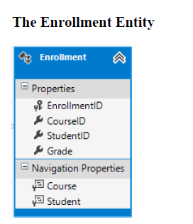

namespace ContosoUniversity.Models

{

public enum Grade

{

A, B, C, D, F

}

public class Enrollment

{

public int EnrollmentID { get; set; }

public int CourseID { get; set; }

public int StudentID { get; set; }

public Grade? Grade { get; set; }

public virtual Course Course { get; set; }

public virtual Student Student { get; set; }

}

}

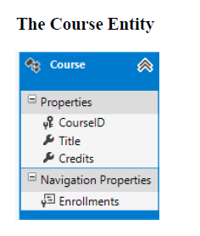

using System.Collections.Generic;

using System.ComponentModel.DataAnnotations.Schema;

namespace ContosoUniversity.Models

{

public class Course

{

[DatabaseGenerated(DatabaseGeneratedOption.None)]

public int CourseID { get; set; }

public string Title { get; set; }

public int Credits { get; set; }

public virtual ICollection<Enrollment> Enrollments { get; set; }

}

}

**Create the Database Context**

**New Folder**: DataAccess

using ContosoUniversity.Models;

using System.Data.Entity;

using System.Data.Entity.ModelConfiguration.Conventions;

namespace ContosoUniversity.DAL

{

public class **SchoolContext** : **DbContext**

{

public SchoolContext() : **base("SchoolContext")**

{

}

public DbSet<Student> Students { get; set; }

public DbSet<Enrollment> Enrollments { get; set; }

public DbSet<Course> Courses { get; set; }

protected override void OnModelCreating(DbModelBuilder modelBuilder)

{

modelBuilder.Conventions.Remove<PluralizingTableNameConvention>();

}

}

}

To tell Entity Framework to use your initializer class, add an element to the entityFramework element in the application *Web.config* file (the one in the root project folder), as shown in the following example:

<entityFramework>

<contexts>

<context type="ContosoUniversity.DAL.SchoolContext, ContosoUniversity">

<databaseInitializer type="ContosoUniversity.DAL.SchoolInitializer, ContosoUniversity" />

</context>

</contexts>

<defaultConnectionFactory type="System.Data.Entity.Infrastructure.LocalDbConnectionFactory, EntityFramework">

<parameters>

<parameter value="v11.0" />

</parameters>

</defaultConnectionFactory>

<providers>

<provider invariantName="System.Data.SqlClient" type="System.Data.Entity.SqlServer.SqlProviderServices, EntityFramework.SqlServer" />

</providers>

</entityFramework>

*Web.config* file and add a connectionStrings

connectionStrings>

<add name="SchoolContext" connectionString="Data Source=(LocalDb)\v11.0;Initial Catalog=ContosoUniversity1;Integrated Security=SSPI;" providerName="System.Data.SqlClient"/>

</connectionStrings>

<appSettings>

<add key="webpages:Version" value="3.0.0.0" />

<add key="webpages:Enabled" value="false" />

<add key="ClientValidationEnabled" value="true" />

<add key="UnobtrusiveJavaScriptEnabled" value="true" />

</appSettings>

**Creating a Student Controller and Views**

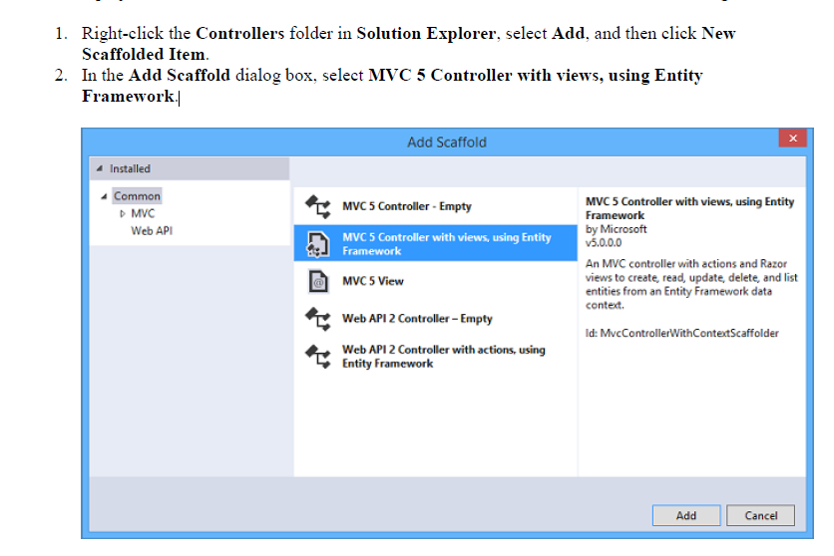

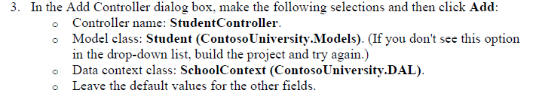

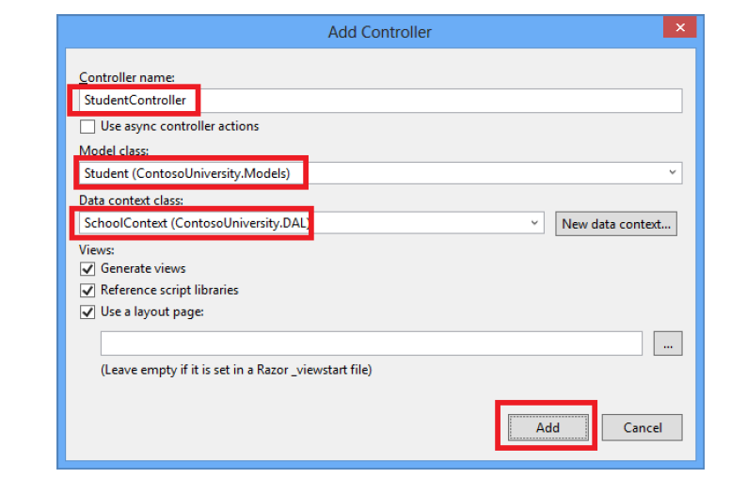

4. Visual Studio opens the *Controllers\StudentController.cs* file. You see a class variable has been created that instantiates a database context object:

private SchoolContext db = new SchoolContext();

public ViewResult Index()

{

return View(db.Students.ToList());

}

The *Student\Index.cshtml* view displays this list in a table:

<table>

<tr>

29

<th>

@Html.DisplayNameFor(model => model.LastName)

</th>

<th>

@Html.DisplayNameFor(model => model.FirstMidName)

</th>

<th>

@Html.DisplayNameFor(model => model.EnrollmentDate)

</th>

<th></th>

</tr>

@foreach (var item in Model) {

<tr>

<td>

@Html.DisplayFor(modelItem => item.LastName)

</td>

<td>

@Html.DisplayFor(modelItem => item.FirstMidName)

</td>

<td>

@Html.DisplayFor(modelItem => item.EnrollmentDate)

</td>

<td>

@Html.ActionLink("Edit", "Edit", new { id=item.ID }) |

@Html.ActionLink("Details", "Details", new { id=item.ID }) |

@Html.ActionLink("Delete", "Delete", new { id=item.ID })

</td>

</tr>

}